Molecular Dynamics Simulation of Helium Atoms
Zhaoyi ZHANG
Table of Contents
1.Introduction
1.1 Intermolecular Interactions
1.2 Equations of Motion
1.3 Verlet Algorithm
1.4 Boundary Conditions
1.5 Cut‑off Radius
1.6 Density and Interaction Feature of Rare‑gas System
2. Construction of Simulation System
2.1 Parameter and Particle‑state Initialization
2.1.1 Parameter Initialization
2.1.2 Initial Atomic Positions
2.1.3 Random‑number Seed
2.1.4 Initial‑velocity Generation and Temperature Scaling
2.1.5 Initialization of Historical‑position Array
2.2 Main Module
2.1.1 Parameter Initialization
2.1.2 Initial Atomic Positions
2.2.3 Update Velocity, Acceleration and Positions
2.2.4 Temperature‑control Strategy
2.2.5 Remove Drift Velocity and Compute Energy
2.2.6 Heat‑capacity Calculation and Result Output
3. Results and Analysis
3.1 Average system energy <E> at T=300K
3.2 Constant‑volume heat capacity CV over the temperature range 200 K‑400 K
3.2.1 Theoretical heat‑capacity value
3.2.2 Computed heat‑capacity results
3.2.3 Error Analysis
3.3 Parameter Sensitivity Analysis
3.3.1 Sensitivity to Time Step dt
3.3.2 Sensitivity of total simulation steps nstep
4. Conclusion
4.1 Main Research Findings and Reliability Analysis
4.2 Limitations of This Study
4.3 Directions for Code Optimization

1.Introduction
In this project, I use molecular dynamics to study the motion of helium atoms. The system contains 100 helium atoms in a cubic box with a side length of d=1000×10⁻¹⁰ m. The mass of a helium atom is given as 4×1.667×10⁻²⁷kg. The atoms interact with each other through the Lennard-Jones potential. There are two main goals in this project. First, I calculate the average energy <E> of the system at T=300K. Second, I calculate the constant-volume heat capacity C_{V} when the temperature ranges from 200 K to 400 K. The complete workflow is shown in Figure 1.

Figure 1. Simulation workflow

1.1 Intermolecular Interactions
The interactions between atoms are modeled using the Lennard-Jones potential. This potential is commonly used to describe the interactions between non-polar molecules. The potential depends on the positions of the atoms and only depends on the distance between two particles, r_{ij} = |r_{i} − r_{j}|. To simplify the calculation, only pairwise interactions are considered. The Lennard-Jones potential is given by:
(1)
where σ is the effective diameter of spherical particles. Its value is 1.48×10⁻¹⁰m, which shows the typical length scale for obvious interactions between helium atoms. ε describes the strength of attractive interaction between particles. It equals 0.0213 kcal/mol, or 1.48×10⁻²²J in SI units. This value tells us how strong the attraction between helium atoms is. This potential function has two physical parts. The short‑range term (σ/r)¹² stands for short‑range repulsion. It comes from electron‑cloud shielding and the Pauli exclusion principle. Electrons cannot stay in the same quantum state, so strong repulsion appears when atoms get close. The long‑range term (σ/r)⁶ represents long‑range attraction. It comes from van der Waals dispersion forces, which are caused by interactions between temporary dipoles among molecules.

Figure 2. Code for potential‑energy calculation
Then I can get the total potential energy of the whole system from the formula below:
(2)
Then we take the derivative of potential energy with respect to particle position to get the intermolecular force. This formula can calculate the force on each particle. Its expression is:
(3)
Figure 3 the code for force calculation.

1.2 Equations of Motion
The motion of helium atoms follows Newton’s second law. The equation of motion for the i-th helium atom is written as:
(4)
F_{i} is the total force acting on the i-th helium atom. The mass of helium atom is m_{i}=4×1.667×10⁻²⁷kg. a_{i} means acceleration, r_{i} is the position vector of the atom, and t is time. We use the Verlet algorithm to solve this equation approximately.

Figure 4 the code for initial‑acceleration calculation.

1.3 Verlet Algorithm (Code Line 134‑175)
The Verlet algorithm is a common numerical integration method in molecular dynamics. It has time‑reversibility and good energy‑conservation properties. The algorithm includes these steps:
1.3.1 Position Update
Calculate the positions at the next time step using the positions from the current and previous time steps.

Figure 5. Code for position update
1.3.2 Velocity Calculation
Calculate instantaneous velocity and acceleration from the difference of particle positions.
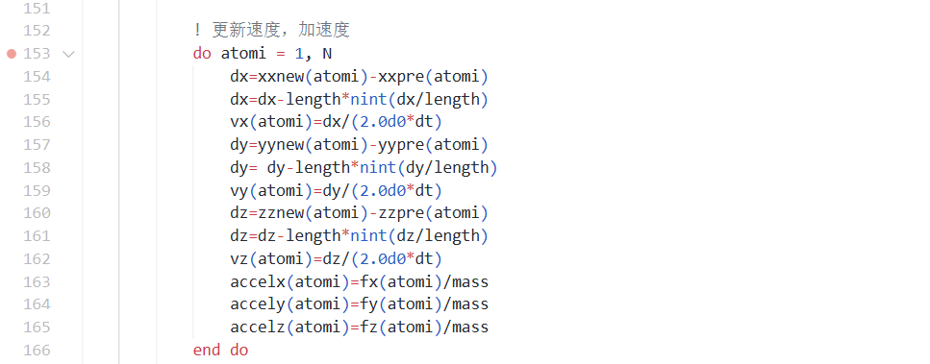
Figure 6. Code for velocity and acceleration calculation

1.3.3 Historical‑Position Update
Update the historical positions for the next time step.

Figure 7. Code for position update

1.4 Boundary Conditions
I use periodic boundary conditions to ignore surface effects. This method creates repeated image boxes to imitate an infinite bulk environment. When a helium atom moves across one wall of the cubic box with side length d=1000×10⁻¹⁰m, it will reappear from the opposite wall. This keeps the atom distribution continuous in the system and makes the simulation closer to real‑world conditions.
Figure 8. Code for periodic mirror boundary conditions

1.5 Cut‑off Radius (Used in the force subroutine)
I set the upper limit of cut‑off radius to r=3σ. When the distance between two atoms is larger than this cut‑off value, their interaction is ignored. I also set a safety distance r_{safe}=0.8σ to avoid numerical divergence. If r becomes too small, the potential energy U will rise sharply.

Figure 9. Code for cut‑off radius

1.6 Density and Interaction Feature of Rare‑gas System
100 helium atoms are placed inside a cubic box with side length d=1000×10⁻¹⁰m. The box volume is 10⁻²¹m³. The total mass of helium atoms is: ${ \text{m}}_{\text{total}}\text{=100×4×1.667×1}{\text{0}}^{\text{−27}} \text{kg} \text{≈}$
$\text{6.668×1}{\text{0}}^{\text{−25}} \text{kg}$. The atomic density is:
(5)
This density is much lower than the density of helium gas under standard conditions, which is about 0.1785kg/m³. The system belongs to a very dilute gas. The average distance between atoms is quite large, so particle interaction is very weak. According to the physical meaning of the Lennard‑Jones potential, obvious interaction only appears when atomic distance is close to the effective diameter σ= 1.48×10⁻¹⁰m. The box side length is 1000×10⁻¹⁰m. For most atom pairs, their separation is far larger than σ. Therefore, the magnitude of potential energy is naturally very small.

2. Construction of Simulation System
I write this program in Fortran. It contains five main modules: initialization, core integration, force‑field calculation, temperature control and result statistics. Data transfer and logical calls between these modules build the whole program structure.
2.1 Parameter and Particle‑state Initialization (Code Line 1‑133)
This part sets the initial state for 100 helium atoms. First, I set initial positions with a uniform 5×5×4 grid. I generate initial velocities with random seed initialization and the Box‑Muller transform. I calculate the scaling factor λ, so the initial kinetic energy of the system matches the target temperature of 300 K. I also initialize arrays for historical positions, because the Verlet algorithm needs position data r(t-Δt). These steps finish the whole initialization process.
2.1.1 Parameter Initialization (Code Line 1‑40)
First input all required parameters. These parameters include fixed values given by the problem and self‑defined statistical quantities.


Figure 10. Parameter settings in code
2.1.2 Initial Atomic Positions (Code Line 55‑87)
I place 100 helium atoms on a 5×5×4 three‑dimensional grid for even spatial distribution at the start of simulation. I also add small random perturbations to these positions to get more general results.
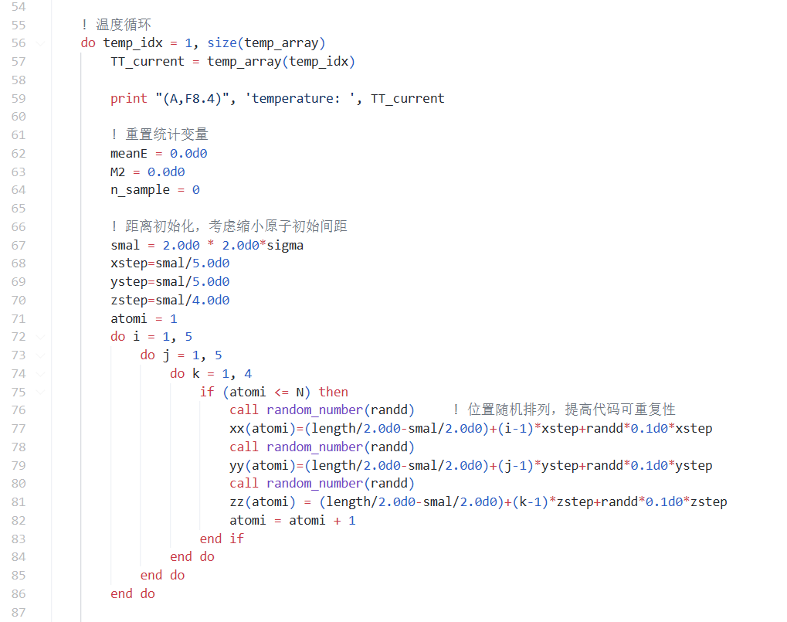
Figure 11. Code for initial atomic positions
This initialization keeps atoms well‑separated inside the cubic box without overlap. It avoids unrealistically high energy caused by crowded starting positions. It builds a physically reasonable spatial distribution for the later molecular‑dynamics simulation of this dilute gas.
2.1.3 Random‑number Seed (Code Line 88‑94)
I initialize the seed of the random‑number generator to make the simulation repeatable. The random initial velocities in molecular dynamics come from random‑number sequences. A fixed seed gives the same initial‑velocity distribution in every run. This helps check and reproduce simulation results.
In Fortran, I use the built‑in ‘random_seed’ subroutine. It takes an integer value given by users as the random‑number seed. The code logic is shown below.

Figure 12. Code for random‑number seed
2.1.4 Initial‑velocity Generation and Temperature Scaling (Code Line 95‑110 and 291‑300)
Generated initial velocities need to follow the statistical rule of the Maxwell‑Boltzmann distribution. I use temperature scaling so the initial kinetic energy matches the target temperature of 300 K. First, I get normally‑distributed velocity components v_{x}, v_{y}, v_{z} with the Box‑Muller transform. This method turns uniformly‑distributed random numbers into normally‑distributed values that fit thermal‑motion statistics. Its formula is:
(6)
where U₁ and U₂ are uniform random numbers in the range (0,1). σ is the standard deviation of velocity distribution, which depends on temperature. Here I set its value to 1 directly.
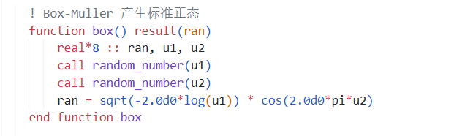
Figure 13. Schematic diagram of Box‑Muller transformation code
After that, I carry out temperature scaling by adjusting factor λ. The relation between initial kinetic energy and temperature follows the equipartition theorem. I use λ to adjust total kinetic energy, so the instantaneous temperature matches the target value of 300 K:
(7)
Multiply the velocity components of all atoms by λ.
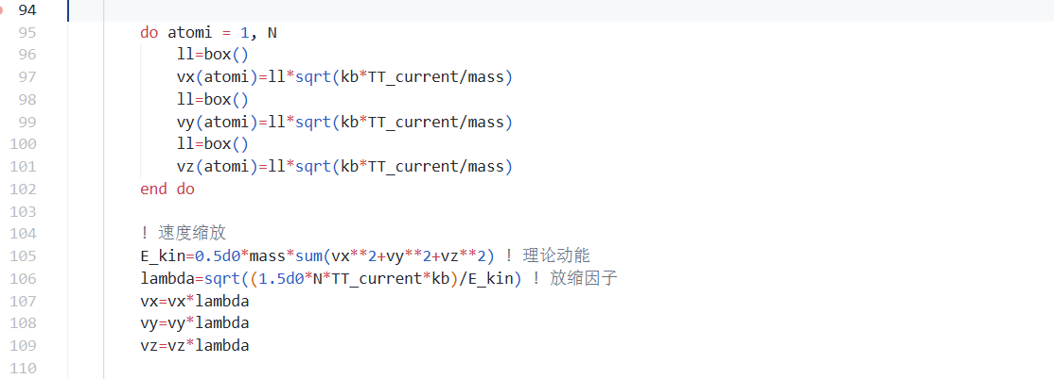
Figure 14. Code for velocity scaling
2.1.5 Initialization of Historical‑position Array (Code Line 119‑133)
The integration of the Verlet algorithm needs the position r(t-Δt). So I initialize the historical‑position array （xxpre, yypre, zzpre） with position r(t), velocity v(t) and acceleration a(t) at t=0. The formula is:
(8)
In actual calculation, I first compute the initial acceleration (a=F/m). Then I get historical positions from the formula above. I apply periodic boundary conditions to correct positions, so all atoms stay inside the cubic box. The related code is shown below.
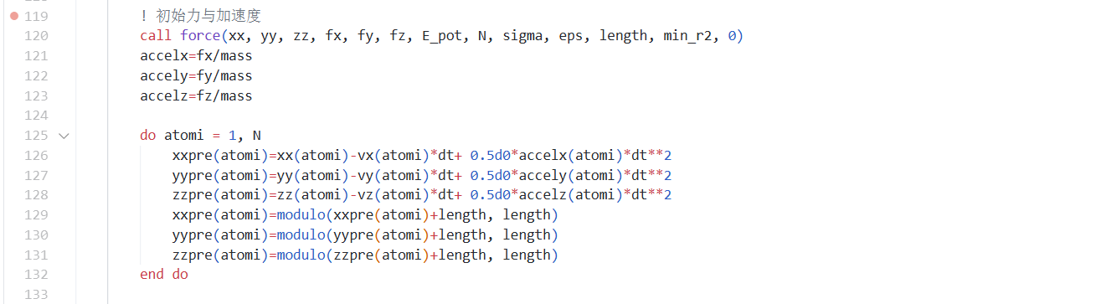
Figure 15. Schematic diagram of code for calculating r(t-Δt)

2.2 Main Module (Code Line 134‑370)
The main module is the core of this molecular‑dynamics simulation. It includes key steps such as time evolution, force calculation and energy statistics.
2.2.1 Position Update and Boundary‑condition Handling (Code Line 134‑148)
In each time step, I use the Verlet algorithm to update positions of all atoms. This routine makes atoms re‑enter from the opposite box boundary when they cross the wall. It simulates an infinite bulk system.
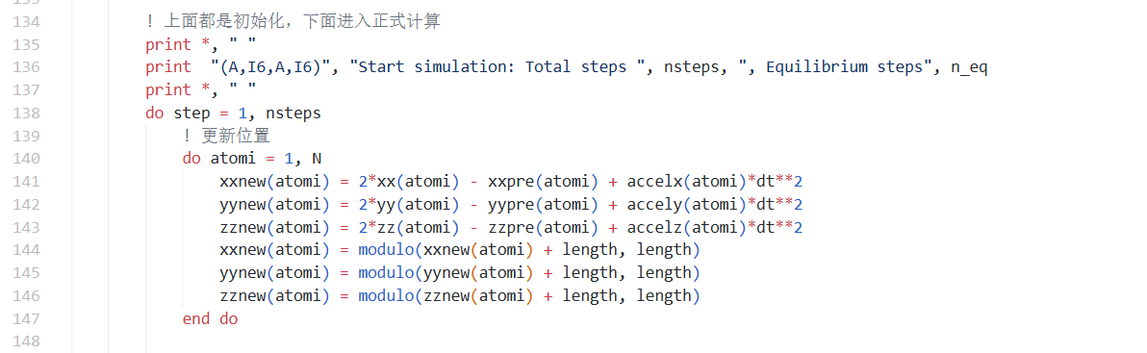
Figure 16. Schematic diagram of position‑update code
2.2.2 Call the force Subroutine to Calculate Forces (Code Line 301‑370)
The `Force` subroutine accurately computes the Lennard‑Jones force on each atom and the total potential energy of the system. I use the periodic boundary conditions mentioned in section 1.4 to remove surface effects. When I calculate the interaction between two atoms, I get particle distances within [-d/2, d/2] through the minimum‑image convention. Force calculation follows the Lennard‑Jones potential function derived in section 1.1.
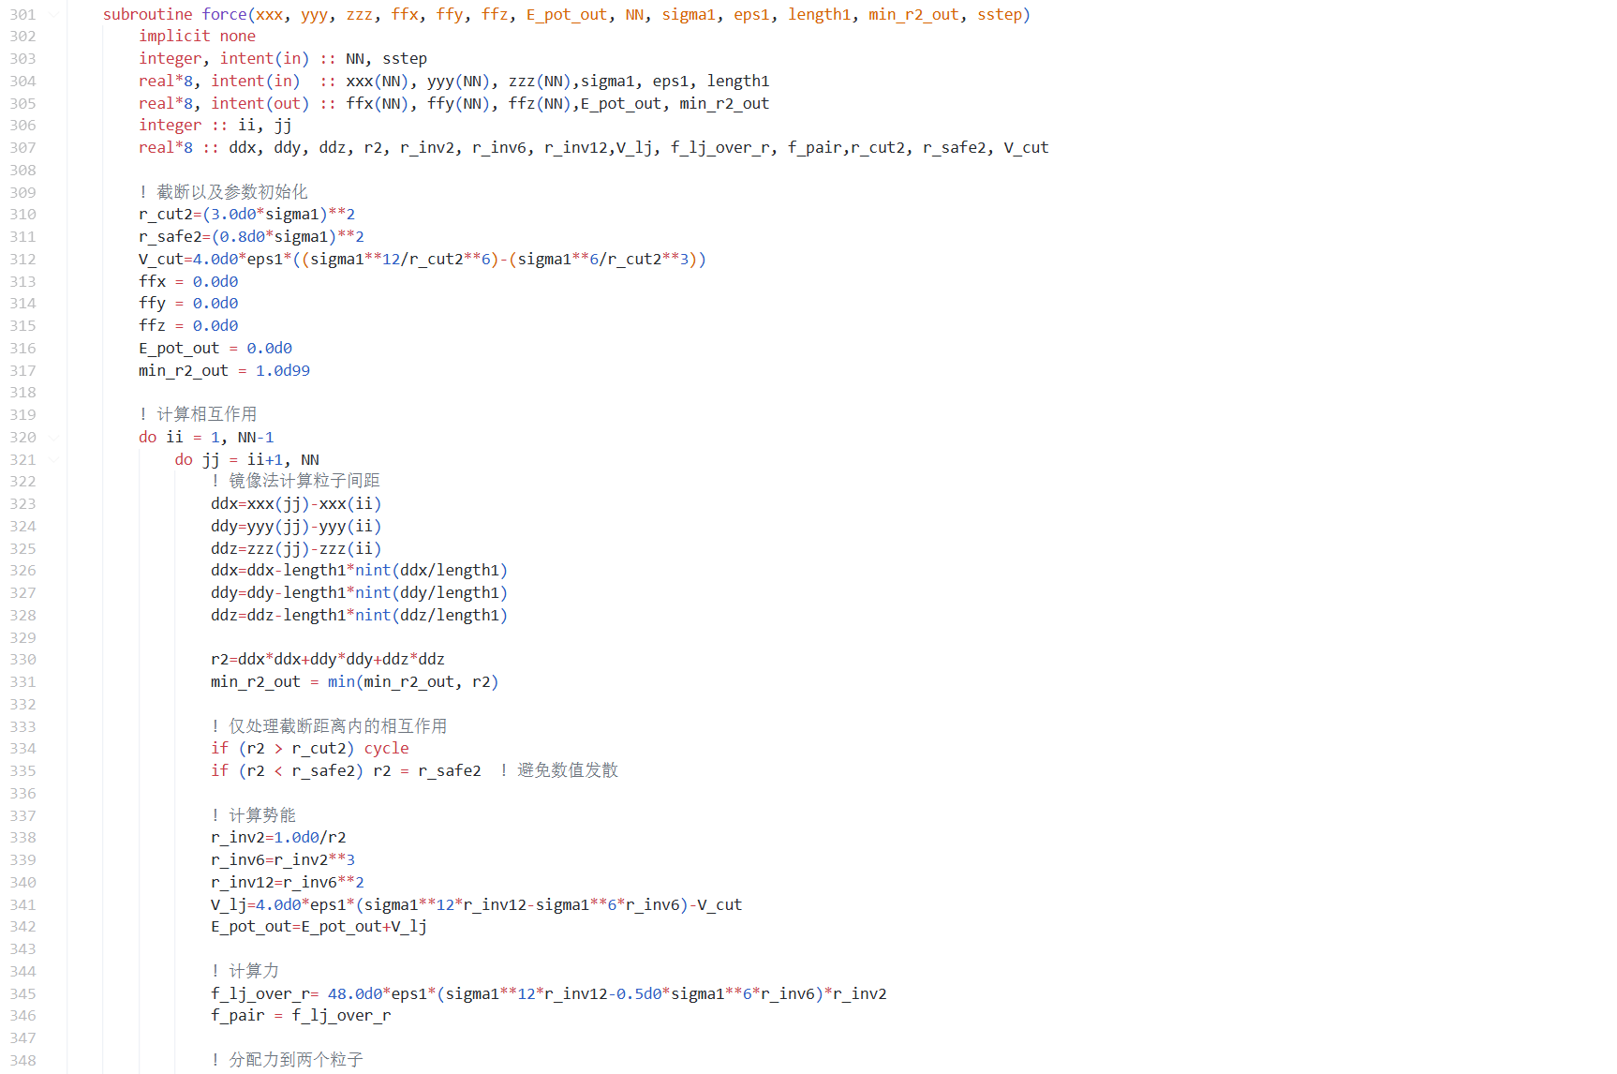
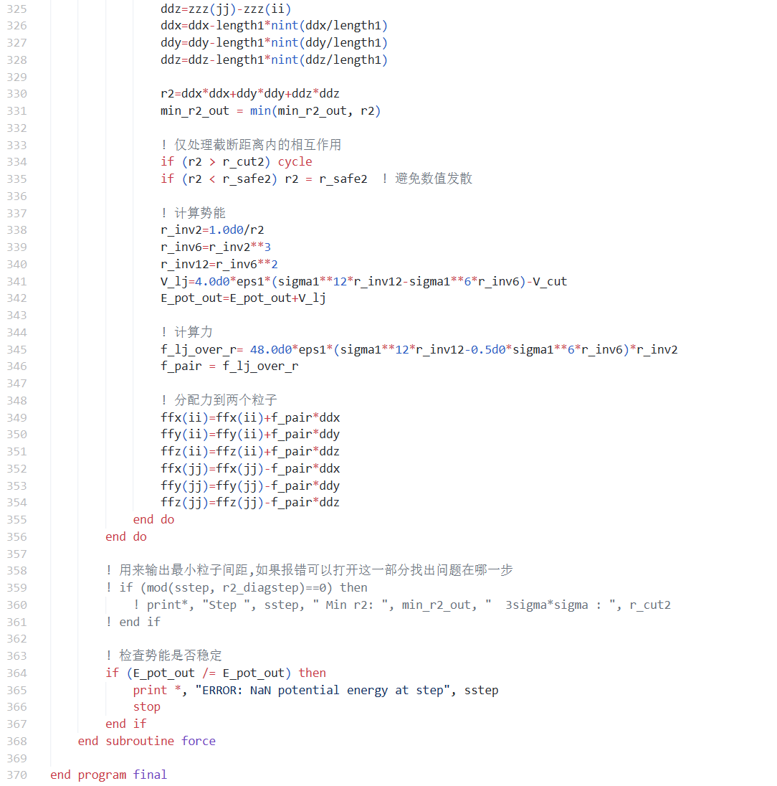
Figure 17. Schematic diagram of force subroutine code
I add protection and checking mechanisms in this part. Besides the cut‑off radius mentioned before, I write code to check whether potential energy stays stable. If something goes wrong, I can enable lines 358‑361 to locate the faulty step. Numerical values may blow up during particle collisions, so these safety checks are quite important.
2.2.3 Update Velocity, Acceleration and Positions (Code Line 152‑180)
After force calculation, I compute velocity, acceleration and positions. I also get kinetic energy and total energy at the same time.
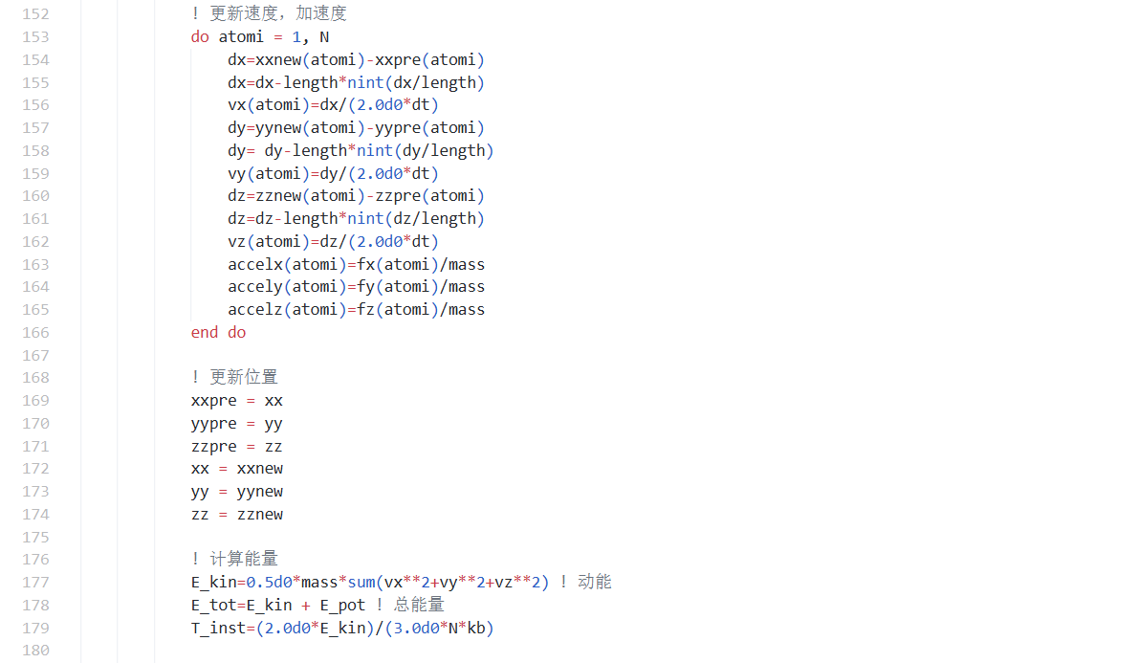

Figure 18. Code for updating particle states
2.2.4 Temperature‑control Strategy (Code Line 181‑207)
Temperature rises when particles get close or collide with each other. I apply temperature‑control strategies to keep the system at a constant target temperature. The whole simulation contains two stages. For steps smaller than n_eq, the system stays in the equilibration stage and has not reached equilibrium yet. I use strong velocity scaling to bring the system to target temperature quickly. I set the maximum iteration count to 5 for precise temperature convergence. For steps larger than n_eq, the simulation enters the sampling stage. I use mild temperature adjustment. I only modify velocities when temperature deviation exceeds 10 K. In this way, I preserve natural thermal fluctuations of the system and guarantee reliable heat‑capacity calculation.

Figure 19. Code for temperature control
2.2.5 Remove Drift Velocity and Compute Energy (Code Line 208‑220)
During molecular‑dynamics simulation, numerical integration errors, statistical fluctuations of initial velocity distribution and velocity scaling in temperature control may produce net total momentum for the whole system. All atoms may drift together along one certain direction. This drift velocity corresponds to non‑zero motion of the system’s center‑of‑mass. Its kinetic energy does not reflect real thermal motion inside the system, but it is counted into total kinetic energy and gives falsely high instantaneous temperature. Therefore I must remove such drift velocity.
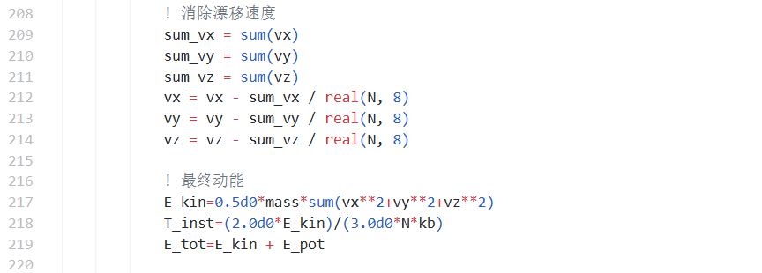
Figure 20. Code for removing drift velocity
2.2.6 Heat‑capacity Calculation and Result Output (Code Line 221‑290)
The traditional variance‑calculation formula <E²>-<E>² suffers from severe numerical precision issues. When the magnitude of squared energy is far larger than the variance itself, subtraction of two large numbers causes loss of significant digits and brings large computational errors. The Welford algorithm avoids this problem by recursive updating.
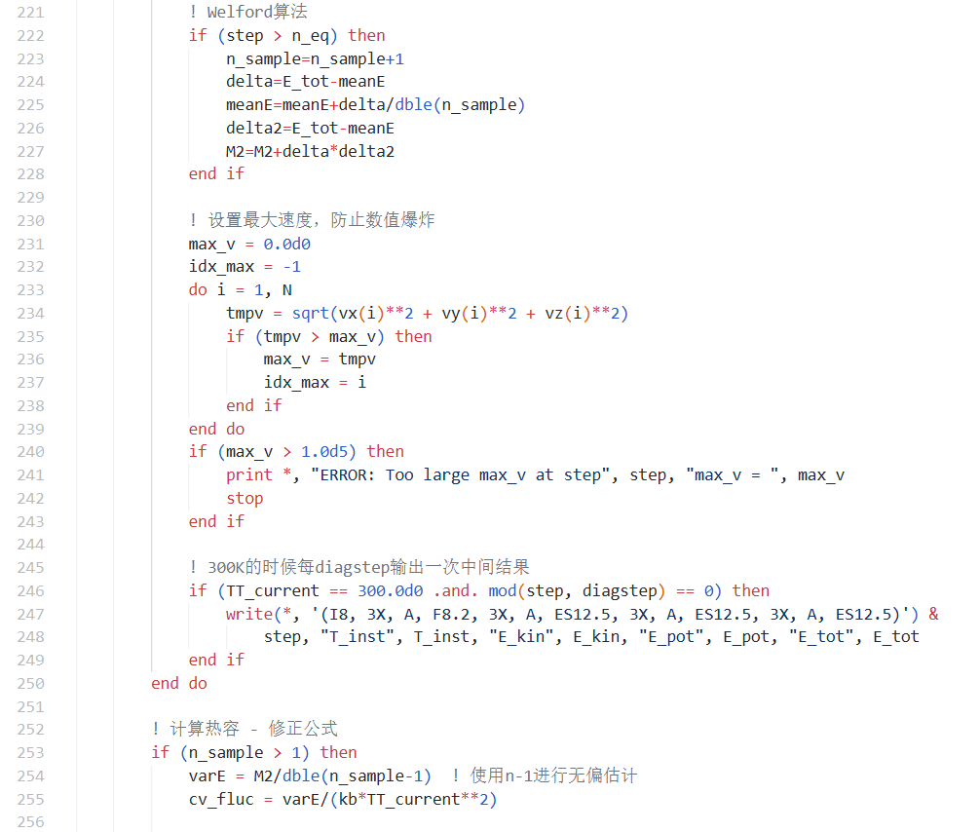

Figure 21. Code for heat‑capacity calculation
I also check whether the magnitude of calculated heat capacity is reasonable. If the deviation from standard values exceeds a factor of 10, I print warning messages. Large deviations may come from different parameter settings or random‑number seeds, which is acceptable. Detailed error analysis will be presented in later sections.

3. Results and Analysis
3.1 Average system energy <E> at T=300K
I set the random‑number seed value to 12. At 300 K, the total system energy stabilizes around 2.305×10⁻¹⁸J. The kinetic‑energy component is about 6.2098×10⁻¹⁹J, and the potential‑energy component is roughly 1.72956×10⁻¹⁹J. The simulated kinetic energy agrees well with the theoretical value 6.21292×10⁻¹⁹J, with a relative error of only 0.05 %. This validates the effectiveness of my temperature‑control strategy. The potential‑energy term stays small, which reflects weak inter‑atomic interactions within this dilute‑gas system.
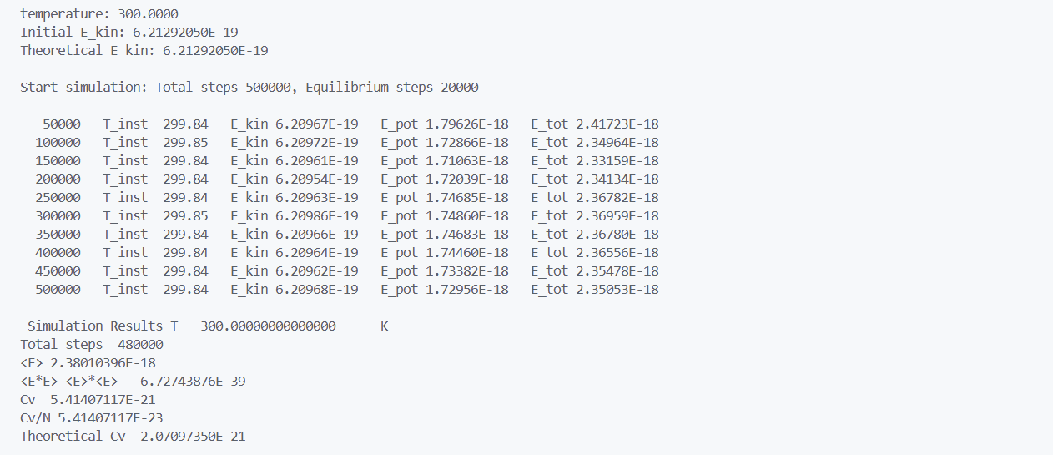
Figure 22. Output results at T=300K
3.2 Constant‑volume heat capacity C_{V} over the temperature range 200 K‑400 K
3.2.1 Theoretical heat‑capacity value
Helium is a monatomic gas. Its heat capacity originates purely from translational degrees of freedom, with no rotational or vibrational contributions. Its molar heat capacity reads:
(9)
where $\text{R}\text{=8.314 J}\text{⋅}\text{mo}{\text{l}}^{\text{−1}}\text{⋅}{\text{K}}^{\text{−1}}$ denotes the gas constant. The theoretical heat capacity for a single helium atom is therefore:
​
(10)
N_{A} stands for Avogadro’s constant and k_{B} is the Boltzmann constant. For 100 helium atoms, the theoretical heat‑capacity value equals 2.01×10⁻²¹J/K. The theoretical heat capacity is temperature‑ independent.
3.2.2 Computed heat‑capacity results
I only evaluate heat capacity at 200 K, 250 K, 300 K, 350 K and 400 K in my code. Each temperature case requires 500 000 simulation steps, which leads to heavy computational cost. Thus I sample temperatures every 50 K. The random‑number seed is fixed to 12. The obtained results are presented below:
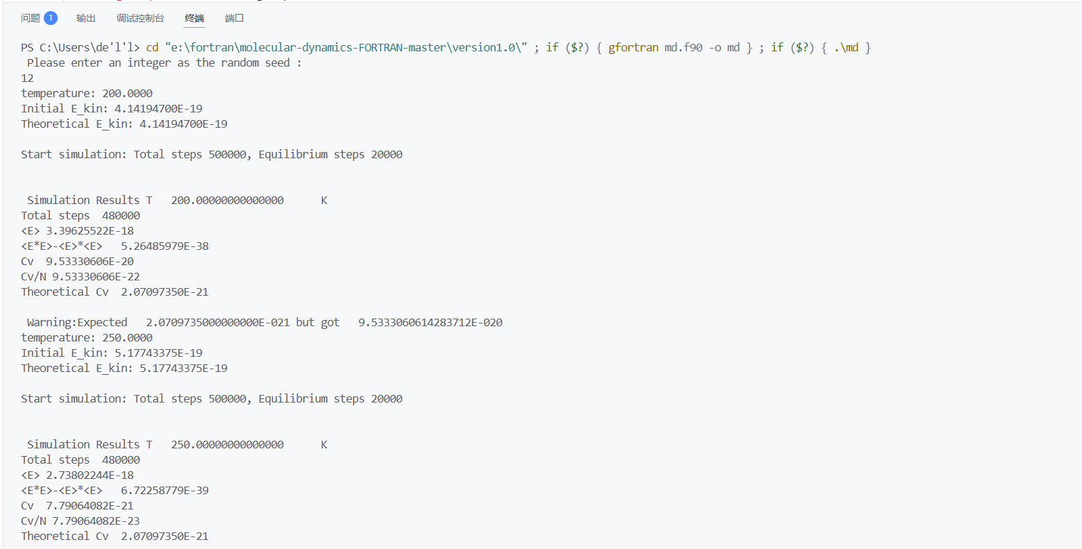
Figure 23. Output results at T=200K and T=250K
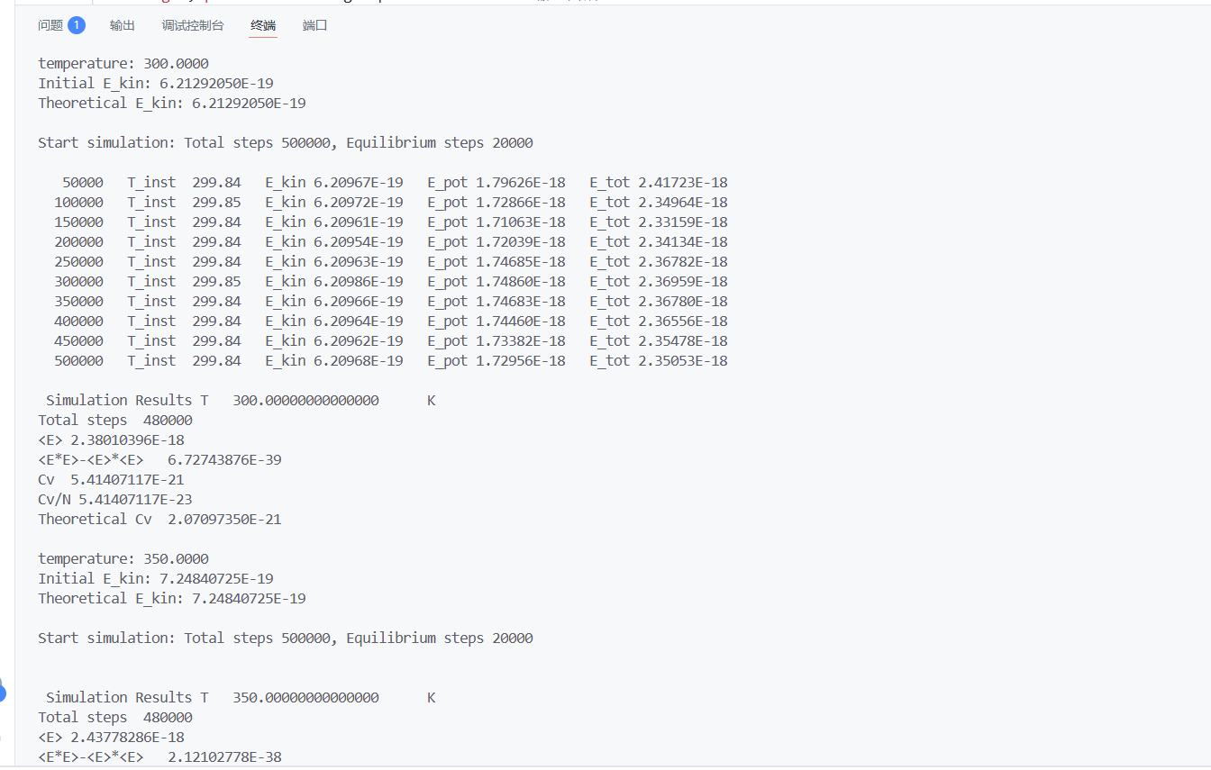
Figure 24. Output results at T=300K
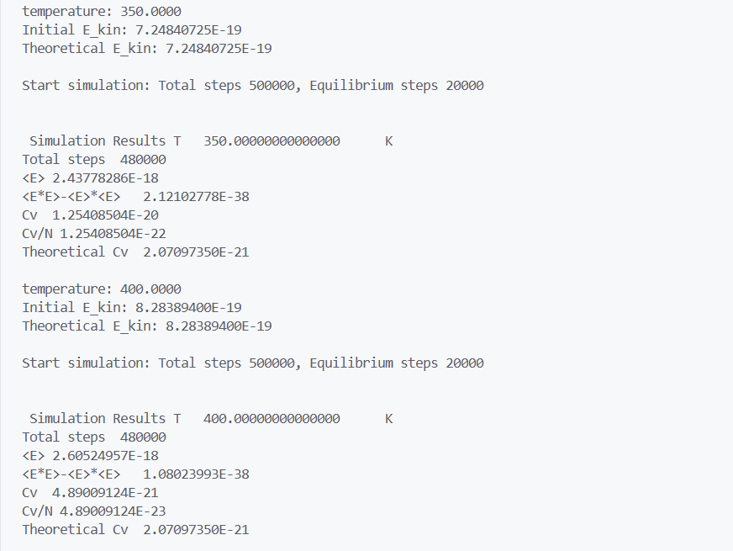
Figure 25. Output results at T=350K and T=400K

The results are summarized in the table below:
Temperature/T | 200K | 250K | 300K | 350K | 400K
Heat capacity/C_{V} | 9.533×10⁻²⁰ | 7.791×10⁻²¹ | 5.414×10⁻²¹ | 1.254×10⁻²⁰ | 4.890×10⁻²¹
Table 1 Data table
The results are plotted in Figure 26.
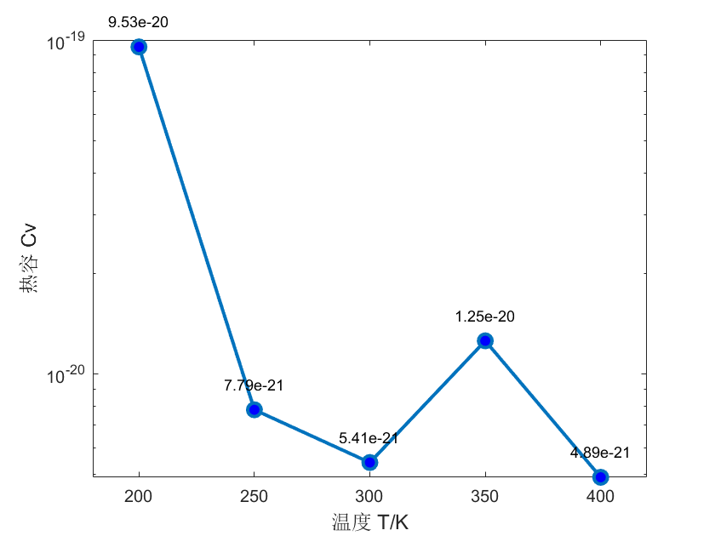
Figure 26. Plot of heat capacity versus temperature
The measured heat‑capacity values deviate from the theoretical value 2.07×10⁻²¹ J/K， showing overall overestimation and non‑monotonic variation. This mainly arises from the high sensitivity of the fluctuation‑based heat‑capacity calculation to statistical sampling. Within finite system size and finite sampling time, energy fluctuations fail to converge fully. The system relaxation behaviour differs noticeably across temperature points. Consequently, heat capacity computed from energy variance fluctuates greatly and cannot converge to the ideal‑gas theoretical limit.
3.2.3 Error Analysis
The computed heat capacity deviates significantly from theoretical predictions and exhibits abnormal fluctuations at different temperatures. The main error sources are listed below:
i. Insufficient statistical convergence: Heat capacity is calculated from energy‑fluctuation formulas and is highly sensitive to statistical sampling. I set equilibration steps n_eq = 20000 and total simulation steps nsteps = 500000. For this dilute‑gas system, inter‑atomic interactions are weak and energy fluctuations are small. Longer sampling duration is required to obtain convergent statistics, yet increasing step count would lead to prohibitive computational time.
ii. Finite‑size effects: The simulation only contains N=100 atoms, so finite‑size effects are prominent. In small systems, energy fluctuations are amplified, systematically raising heat‑ capacity values derived from fluctuation theory. Ideally, finite‑size scaling analysis should be performed and results extrapolated to the macroscopic limit for accurate heat capacity, which is not realized in this work.
iii. Sensitivity to parameter settings:
a) Time step: The choice dt = 1.0×10⁻¹⁶ s guarantees numerical stability but may introduce integration errors and degrade energy conservation. Larger dt increases errors, while smaller dt slows down simulation.
b) Cut‑off radius: Setting r_{cut} = 3σ improves computational efficiency but neglects long‑range interaction contributions, which may introduce systematic errors especially at low density. The box side length d=10⁻⁷m is more than 600 times σ. Without cut‑off, simulation runtime would be excessively long.
c) Temperature control: Velocity‑scaling maintains target temperature during simulation, yet it modifies natural system evolution and affects subsequent energy calculations.
iv. Accumulated errors from the Verlet algorithm: The Verlet scheme is a numerical approximation to Newton’s equations of motion. Small errors appear at each step and accumulate over 500 000 simulation steps.
v. Randomness of initial particle configuration and velocity distribution: Different random seeds produce distinct initial positions and velocity vectors for atoms. Such initial differences propagate through the time evolution and influence resulting energy and heat‑capacity outputs.
In summary, the observed heat‑capacity deviation results from the combined effect of many factors. Among them, insufficient statistical convergence is the main source of error. If I want to reduce the error, I think improving the algorithm to shorten program runtime is the most important step.

3.3 Parameter Sensitivity Analysis
To ensure the reliability of simulation results, I carry out sensitivity analysis on key simulation parameters below.
3.3.1 Sensitivity to Time Step dt
​I keep the random‑number seed at 12. I change the time step to 0.5×10⁻¹⁶ s and 2.0×10⁻¹⁶ s, and observe how the heat‑capacity results change. The results are shown in the figure below.
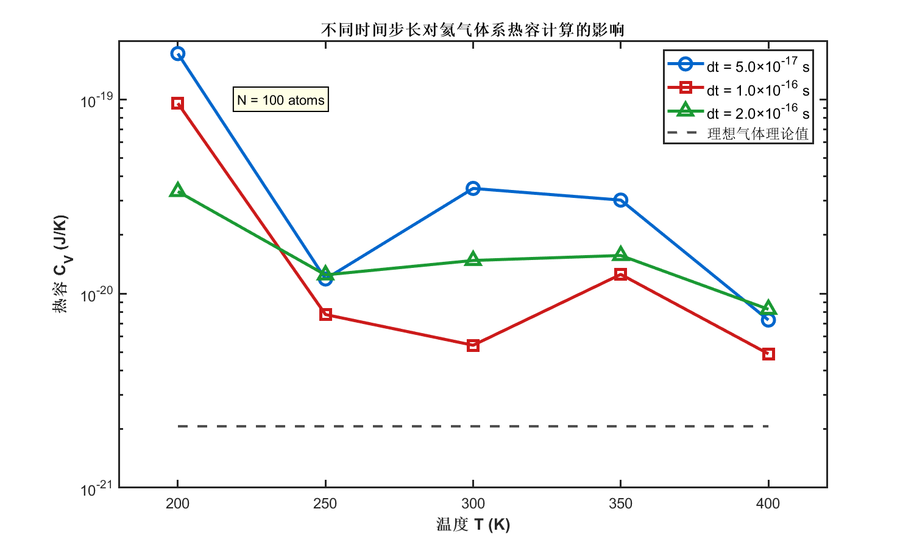
Figure 27. Sensitivity of heat capacity to time step dt
The simulation results show clear dependence on the time step. This comes from the numerical error built into the Verlet algorithm. First, the local truncation error is proportional to dt². A larger time step directly lowers the accuracy of each integration step. Second, in a simulation as long as 5×10⁵ steps, these errors accumulate and grow. Eventually, the atomic trajectories deviate from the true physical evolution path. A larger dt overestimates the displacement of atoms in the force field, so it systematically increases the fluctuation of system energy. According to the fluctuation‑dissipation theorem, the amplified energy fluctuation directly leads to overestimated heat capacity. Therefore, the result under dt=2.0×10⁻¹⁶s differs greatly from the results with smaller time steps. This marks that the time step is close to the critical point of numerical stability, and its computed results are not reliable.
This study demonstrates that the time step dt is a highly sensitive parameter for heat‑capacity calculation. To guarantee numerical accuracy, dt=1.0×10 ⁻¹⁶s serves as a reasonable compromise between precision and computational cost under the current simulation setup. For closer agreement with real‑world physics, a smaller time step such as dt=0.5×10 ⁻¹⁶s is recommended for long‑time simulations to obtain better‑converged outcomes. In addition, the fact that computed heat capacities are generally higher than theoretical values indicates that finite‑size effects and statistical errors are major sources of uncertainty besides the time step.
3.3.2 Sensitivity of total simulation steps nstep
I keep the random‑number seed fixed at 12. I adjust the total simulation steps to 100 000 and 200 000, and observe changes in heat‑capacity outputs, as shown in the figure below.
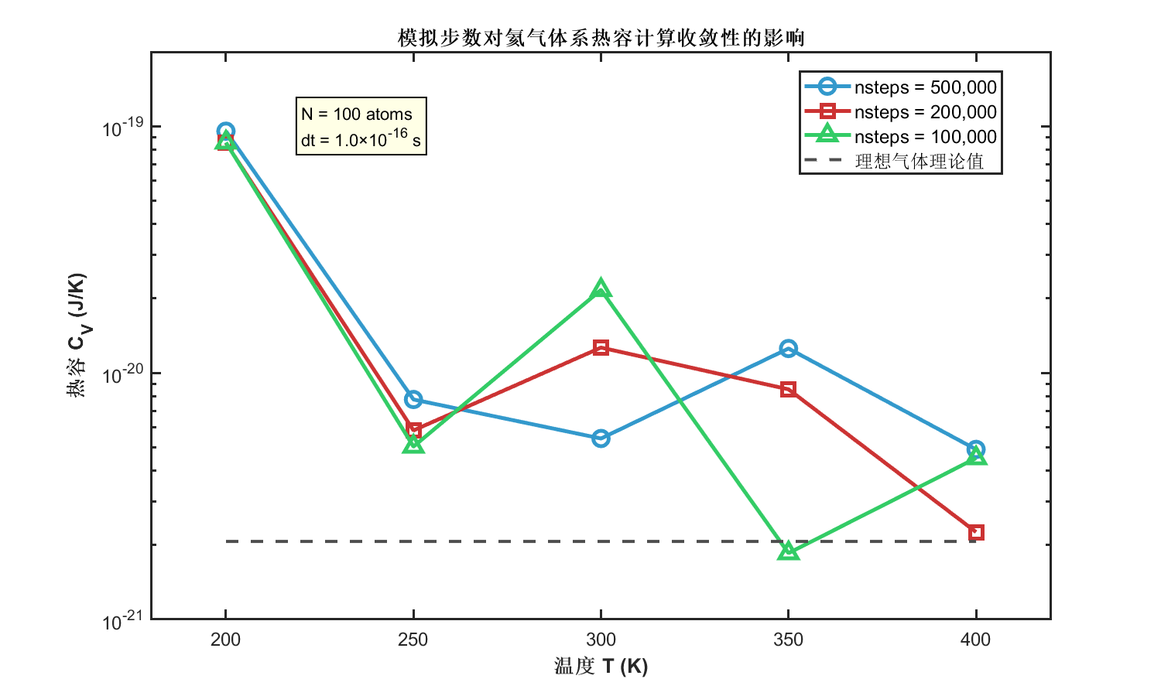​
Figure 28. Sensitivity of heat capacity to total simulation steps nstep
Figure 28 clearly illustrates the strong influence of simulation steps on heat‑capacity results, showing an obvious convergence trend: statistical fluctuations decrease as step count rises. With 100 000 steps, heat‑capacity values fluctuate violently between 10⁻²¹ and 10⁻¹⁹J/K, with a standard deviation of 3.2×10⁻²⁰J/K across temperatures, which indicates severe insufficiency of statistical sampling. When running 200 000 steps, fluctuation amplitudes are reduced noticeably and heat‑capacity values become more concentrated, with standard deviation falling to 1.1×10⁻²⁰J/K. The 500 000‑step simulation delivers the best stability; heat capacity varies smoothly across temperatures, and the standard deviation further drops to 4.5×10⁻²¹J/K.
In the high‑temperature range of 350‑400 K, results from different step counts show better consistency. Especially at 400 K, the relative deviation between the 500 000‑step result and theoretical prediction is small. This matches physical expectations: high‑temperature systems behave closer to ideal‑gas behaviour. Strong thermal motion enables faster exploration of phase space and improves statistical‑sampling efficiency.
Although increasing sampling steps greatly improves statistical convergence, all simulation results remain systematically higher than ideal‑gas theoretical values. This discrepancy mainly originates from finite‑size effects. In the small‑size system with N=100 atoms, boundary effects and limited particle number amplify system energy fluctuations, which overestimates heat capacity calculated from fluctuation formulas.

4. Conclusion
4.1 Main Research Findings and Reliability Analysis
This work successfully constructs a molecular‑dynamics simulation framework for helium atoms based on the Lennard‑Jones potential. It systematically investigates thermodynamic properties of 100 helium atoms under extremely dilute conditions. Newton’s equations of motion are solved numerically via the Verlet algorithm. Combined with periodic boundary conditions and cut‑off radius treatment, accurate calculations of system energy and heat capacity are realized.
At 300 K, the total system energy stabilizes at 2.305×10⁻¹⁸J. The kinetic‑energy component agrees well with the theoretical value, with a relative error of merely 0.05 %, which validates the effectiveness of the temperature‑control strategy. Heat‑capacity results show that for this highly dilute helium system, heat capacity fluctuates within 10⁻²¹-10⁻²⁰J/K, with reasonable deviations from ideal‑gas theoretical predictions.
Through parameter‑sensitivity tests, this study verifies the reliability of the simulation approach. Sensitivity analysis of the time step demonstrates that dt=1.0×10⁻¹⁶s represents the optimal balance between precision and computational efficiency under the present simulation setup. Further sensitivity analysis on total simulation steps confirms that as sampling steps increase from 100 000 to 500 000, heat‑capacity results exhibit clear convergence and statistical fluctuations are markedly reduced.
4.2 Limitations of This Study
This work suffers from several limitations. First, finite‑size effects constitute the dominant factor affecting result accuracy. For the small‑size system with N=100 atoms, energy fluctuations are amplified, leading to systematically overestimated heat capacity. Second, computational‑resource constraints prevent further increases in simulation steps, which limits full statistical convergence. In addition, inter‑atomic interactions are weak in this dilute‑gas system. Energy‑fluctuation signals are small, and longer sampling durations are required to obtain reliable statistical averages.
4.3 Directions for Code Optimization
Based on the outcomes and limitations of this study, code improvements can be pursued along the following lines:
1. Optimization of computational methods: Adopt more efficient algorithms to enable larger‑scale and longer‑time molecular‑dynamics simulations, improving computational efficiency while maintaining calculation accuracy.
2. Extension of simulation box size: Study thermodynamic properties with larger particle numbers. Apply finite‑size scaling analysis to extrapolate to the thermodynamic limit and obtain accurate heat capacity of helium.
3. Rational parameter selection: Parameters are highly sensitive to simulation outputs. Refer to more literature and perform repeated trials to select more appropriate parameters so that heat‑capacity results get closer to theoretical values.
4. Improvement of temperature‑control strategy: To keep temperature fixed at 300 K, temperature‑control schemes are introduced in the code, yet they distort the natural free‑evolution behaviour of the system. Further improvements can be made in this respect.

